**ASSIGNMENT 7 – FETCH DATA USING GRAPHQL**

**Steps :**

Build an application with Apollo client and GraphQL

**Code :**

<https://github.com/hemapunniakotti/ReactProjects/tree/main/Assignment7_GraphqlCountries>

**Output :**

The first page of application should display the list of countries

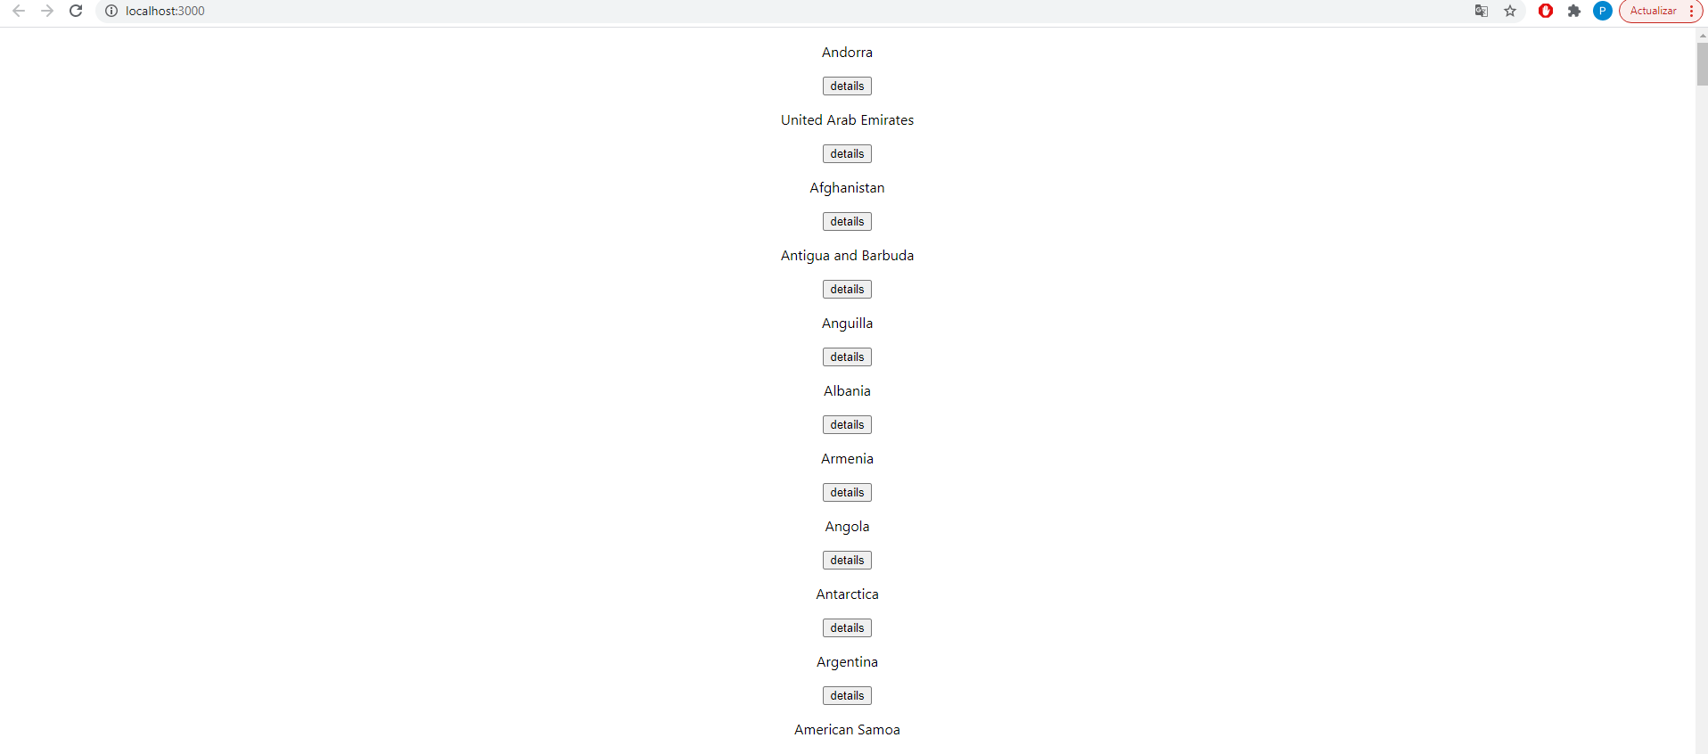

On clicking the details button user should get the details of the respective country

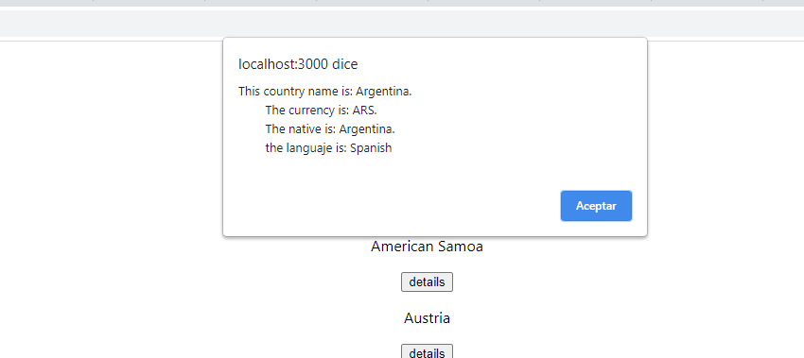

Response

